

<Name-of-Software-Application>

# **CS 230 Project Software Design Template**

Version 1.0

## Table of Contents

**CS 230 Project Software Design Template**1

**Table of Contents**2

**Document Revision History**2

**Executive Summary**3

**Design Constraints**3

**System Architecture View**3

**Domain Model**3

**Evaluation**3

**Recommendations**5

## Document Revision History

| Version | Date | Author | Comments |
| --- | --- | --- | --- |
| 1.0 | <mm/dd/yy> | <Your-Name> | <Brief description of changes in this revision> |

**Instructions**

Fill in all bracketed information on page one (the cover page), in the Document Revision History table, and below each header. Under each header, remove the bracketed prompt and write your own paragraph response covering the indicated information.

## Executive Summary

<Write a summary to introduce the software design problem and present a solution. Be sure to provide the client with any critical information they must know in order to proceed with the process you are proposing.>

## Design Constraints

<Identify the design constraints for developing the game application in a web-based distributed environment and explain the implications of the design constraints on application development.>

## System Architecture View

Please note: There is nothing required here for these projects, but this section serves as a reminder that describing the system and subsystem architecture present in the application, including physical components or tiers, may be required for other projects. A logical topology of the communication and storage aspects is also necessary to understand the overall architecture and should be provided.

## Domain Model

<Describe the UML class diagram provided below. Explain how the classes relate to each other. Identify any object-oriented programming principles that are demonstrated in the diagram and how they are used to fulfill the software requirements efficiently.>

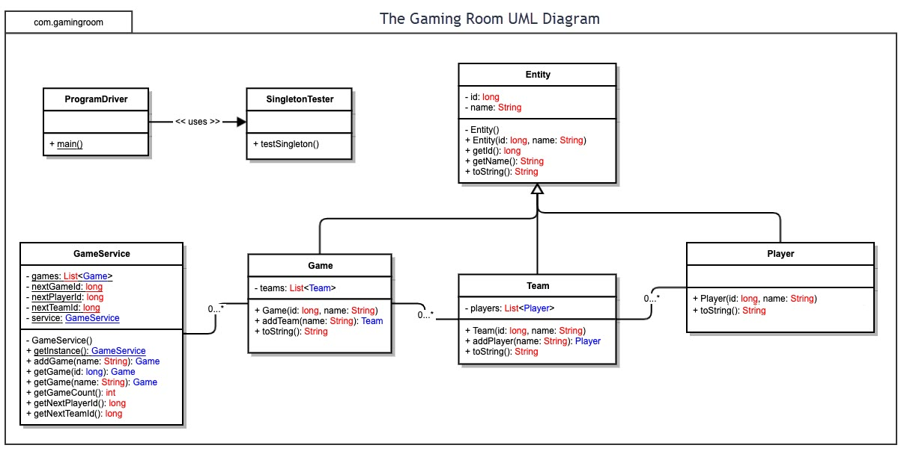

## Evaluation

Using your experience to evaluate the characteristics, advantages, and weaknesses of each operating platform (Linux, Mac, and Windows) as well as mobile devices, consider the requirements outlined below and articulate your findings for each. As you complete the table, keep in mind your client’s requirements and look at the situation holistically, as it all has to work together.

In each cell, remove the bracketed prompt and write your own paragraph response covering the indicated information.

| **Development Requirements** | **Mac** | **Linux** | **Windows** | **Mobile Devices** |
| --- | --- | --- | --- | --- |
| **Server Side** | <Evaluate Mac for its characteristics, advantages, and weaknesses for hosting a web-based software application.> | <Evaluate Linux for its characteristics, advantages, and weaknesses for hosting a web-based software application.> | <Evaluate Windows for its characteristics, advantages, and weaknesses for hosting a web-based software application.> | <Evaluate Mobile Devices for their characteristics, advantages, and weaknesses for hosting a web-based software application.> |
| **Client Side** | <Determine the software development considerations (cost, time, expertise) that are necessary for supporting multiple types of clients as they pertain to Mac.> | <Determine the software development considerations (cost, time, expertise) that are necessary for supporting multiple types of clients as they pertain to Linux.> | <Determine the software development considerations (cost, time, expertise) that are necessary for supporting multiple types of clients as they pertain to Windows.> | <Determine the software development considerations (cost, time, expertise) that are necessary for supporting multiple types of clients as they pertain to Mobile Devices.> |
| **Development Tools** | <Identify the relevant programming languages and tools (IDEs and other tools) that are used to build this type of software for deploying on Mac.> | <Identify the relevant programming languages and tools (IDEs and other tools) that are used to build this type of software for deploying on Linux.> | <Identify the relevant programming languages and tools (IDEs and other tools) that are used to build this type of software for deploying on Windows.> | <Identify the relevant programming languages and tools (IDEs and other tools) that are used to build this type of software for deploying on Mobile Devices.> |

## Recommendations

Analyze the characteristics of and techniques specific to various systems architectures and make a recommendation to The Gaming Room. Specifically, address the following:

1. **Operating Platform**: <Recommend an appropriate operating platform that will allow The Gaming Room to expand Draw It or Lose It to other computing environments.>
2. **Operating Systems Architectures**: <Describe the details of the chosen operating platform architectures.>
3. **Storage Management**: <Identify an appropriate storage management system to be used with the recommended operating platform.>
4. **Memory Management**: <Explain how the recommended operating platform uses memory management techniques for the Draw It or Lose It software.>
5. **Distributed Systems and Networks**: <Knowing that the client would like Draw It or Lose It to communicate between various platforms, explain how this may be accomplished with distributed software and the network that connects the devices. Consider the dependencies between the components within the distributed systems and networks (connectivity, outages, and so on).>
6. **Security**: <Security is a must-have for the client. Explain how to protect user information on and between various platforms. Consider the user protection and security capabilities of the recommended operating platform.>